

**Smart drone in health applications**

**Submitted by**

**Saad Bakheet Alsharif**

**1408300**

**Faculty of Computing and Information Technology**

**King Abdulaziz University**

**Jeddah – Saudi Arabia**

**8/1439H | 4/2018M.**

**بسم الله الرحمن الرحيم**

**قال الله العليم :**

**}إِنَّمَا يَخْشَى اللَّهَ مِنْ عِبَادِهِ الْعُلَمَاءُ {** فاطر:28

**"** عن انس بن مالك رضي الله عنه قال قال صلى الله عليه وسلم( من خرج في طلب العلم كان في سبيل الله حتى يرجع)**"**

المحدث : الترمذي  
خلاصة حكم المحدث : صحيح

**Certification of Research**

I certify that I have reviewed this project done by: ***SAAD ALSHARIF 1408300*** during the ***1st & 2nd*** semester of the academic year ***2018***. And I approve the project submission for discussion by the project responsible committee to grade it as the graduation project degree in ***computer science.***

Supervisor: **Dr .Vijey Thayananthan**

Signature: …………………

**Declaration**

We certify that the implementation of this graduation project has been done by our own efforts. This includes the preparation and writing of the analysis, design, programming and documentation. We have got assistance during the implementation period of this project, after Allah, from the references mentioned in this thesis, and Allah is the witnesses of what we say.

Student Name: SAAD BAKKEET ALSHARIF

Student ID: 1408300

E-mail: SAAD2016X@GMAIL.COM

Mobile: 0567584374

Signature: .............................

**Smart drone in health applications**

**Abstract**

In this project, the aim is using smart functions of the drone in healthcare application is the main aim. Smart functions depend on the use of drone simulator and AI algorithms which allow me to identify the accuracy of the path. The drone will go to its destination with the first aid or medication by taking shortest path using GPS tracking.

**Dedicated to**

To our great families who provided a generous assistant as always during this in order to complete this project.

**Acknowledgments**

Special thanks to **Dr .Vijey Thayananthan** for his and help in achieving the project goals. Thanks to **Dr Shuaib Qureshi** for his coordination and management for the senior project.

Wish you all the best,

Table of contact

Certification of Research 4

Declaration 5

Abstract 6

Dedicated to 7

Acknowledgments 8

List of Figures 12

Chapter 1 : Introduction 15

1.1 Motivation 15

1.2 Consideration 15

1.3 Project Proposal 16

1.3.1 Problem definition 16

1.4 Project scope 16

1.5 Project type 17

1.6 The outcome 17

1.7 Target Users 17

1.8 Suggested solution 18

1.9 Project Management 19

1.9.2 Time Estimates 19

1.9.3 Gantt chart 20

Chapter 2 : Literature Search and Evaluation 22

Summary: 22

Evaluation: 22

Literature search and evaluation 23

[1]" Fault Tolerant Control of a X8-VB Quadcopter" 23

[2]" Quadcopter Simulation and Control Made Easy" 24

[3]" Find Dijkstra's Shortest Path Algorithm" 25

Required skill 26

Skills to be developed 26

Chapter 3 27

Analysis & design 27

Chapter 3 : Analysis & design 28

3.1 Requirements Specification 28

3.1.1 Functional Requirements :- 28

3.1.2 Nonfunctional Requirements :- 28

3.2 Data Requirements :- 28

3.4 Software :- 28

3.5 Activities and Actions 29

3.5.2 Flow chart :- 29

Chapter 4 : Implementation 31

Tools & technologies 31

Interface 32

34

Chapter 5 35

Testing 35

Testing 36

Chapter 6 39

Conclusion 39

Chapter 6 : Conclusion 40

References 42

|  |  |  |  |
| --- | --- | --- | --- |
|  | |  | |
|  | |  | |
|  | |  | |
|  | |  | |
|  | |  | |
|  | |  | |
|  |  | |
|  |  | |

## List of Figures

|  |
| --- |
| **Chapter 1** |
|  |
| **1.1 Figure TimeEstimates…………………………………………………………………………19** |
| **1.2 Figure GanntChart……………………………………………………………………………20** |

**Chapter 3**

**3.1 Figure**

**Data requirement……………………………………………………………………………**

**3.2 Figure flowchart……………………………………………………………………………**

**Chapter 4**

**4.1 Figure**

**ground station……………………………………………………………………………**

**4.2 Figure**

**Command line for control drone……………………………………………………**

**4.3 Figure**

**Drone kit simulator ……………………………………………………………………………**

**4.4 Figure**

**The script of python in grid map …………………………………………………………………**

**4.5 Figure**

**Unity simulator ……………………………………………………………………………**

**Chapter 5**

**5.1 Figure**

**The first case in testing ……………………………………………………………………………**

**5.2 Figure**

**Second case in testing ……………………………………………………………………………**

**5.3 Figure**

**The third case in testing……………………………………………………………………………**

|  |  |  |
| --- | --- | --- |
|  | |  |
|  | |  |
|  | |  |
|  | |  |
|  |  | |
|  |  | |

**Chapter 1**

**Introduction**

**Chapter 1**

# Chapter 1 : Introduction

This is the first progressive report of the senior project. The report will start by describing the smart drone in healthcare application and the problem at hand, initial activities description and suggested solutions. Then, the project schedule will be viewed. After that, a paper of the literature survey is summarized and evaluated. Then, the required software and equipment will be listed. Finally, the future work for the project is decided and explained Drones help us to provide more efficient healthcare to patients who are unable to travel to hospitals or to collect the medicines during the busy time. Within the reasonable distance, drone gives solutions such as transporting medicine between city and village using some techniques related to artificial intelligence.

## 1.1 Motivation

The motivation for the project is learning new things , and since there are so many huge environments ,by the drone we can provide a solution to a lot of problems people are facing these days, unlike the early days relying on just Normal transportation.

## 1.2 Consideration

In this project, we will consider that the hospital is able to send medicines, such as (diabetes treatment or first aid) to the destination.

## 1.3 Project Proposal

### 1.3.1 Problem definition

They are some people who live in remote villages need some medications, or people need first aid. It is required for supplying urgent medical facilities quickly before the ambulances reach the location through the heavy traffic road or crowded places. During the difficult situations such as problems of finding delivery staff, drones can be used for delivering services which are fast and safe to transport the medical packages.

## 1.4 Project scope

Use a simulator drone and AI shortest path algorithms to deliveries package to the exact destination are the scopes of this project. All these points mentioned in the scope shall be integrated together using a drone kit environment. To deliver the medical package, a drone is expected to work smoothly under the perfect environmental conditions.

## 1.5 Project type

The type of the project is a simulation-based project.

## 1.6 The outcome

A drone program that calculates the implementation of a short path algorithm in maps to find (short path).

## 1.7 Target Users

Hospitals are looking for transporting medicine.

Educational institutions are looking for sending first aid to injured students.

## 1.8 Suggested solution

* Give the correct destination.
* Calculate distance using AI algorithm
* Start to fly through the path considered by the algorithm.
* Deliver the package safely.
* Build a database of the path to store the GPS tracking.

## 1.9 Project Management

### 1.9.2 Time Estimates

Figure 1.2 shows you “The time estimates schedule for the project”

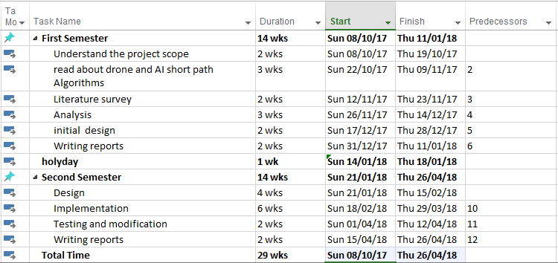

Figure 1.1 - Time Estimates

### 

### 1.9.3 Gantt chart

The following Gantt chart diagram will illustrate the timing of the tasks which are already presented in the Work Breakdown Structure above. Gantt chart will help us to organize our time to finish the project on time.

Figure 1.2 shows you “The Gantt chart schedule for the project”

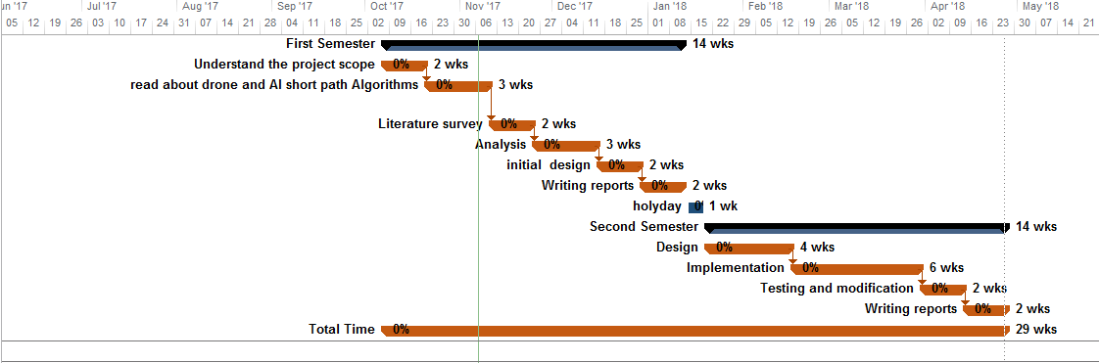

Figure 1.2 - Gantt chart

**Chapter 2**

**Literature Review**

# Chapter 2: Literature Search and Evaluation

The project has been understood generally when I explored all necessary information about the drone. Therefore the subjects needed for the literature review has been identified.

[1]" Fault Tolerant Control of a X8-VB Quadcopter"

[2]" Quadcopter Simulation and Control Made Easy"

[3]" Find Dijkstra's Shortest Path Algorithm"

### Summary:

I studied about the drone and its facilities in healthcare applications. Transporting medicine to the destinations with GPS tracking, taking the shortest path without control, etc. are focused on this report.

### 

### Evaluation:

In the study, smart functions of the drone were evaluated for on-time performance, medication package handling, etc.

Evaluation of this new smart functions will be considered after all the data has been collected.

## Literature search and evaluation

### 

### [1]" Fault Tolerant Control of a X8-VB Quadcopter"

**Summary:-**

The paper provides design and implements the kinematic and dynamic model of a quadcopter with X8 configuration in Simulink®. The model depends on techniques based on the reliable performance of the control systems due to the aircraft model quality.

**Presentation:-**

Until now, the main research effort in multirotors control has been mostly focused on the attitude and trajectory control, considering that the aircraft’ structures do not fail.

**Relevance:-**

The paper provides a model which solves the problem implemented in an over-actuated system. It explains all the steps needed to build a simulator, extract its features and simulator. This project is an about built simulator, so this paper is so this paper is important.

**Objectivity:-**

The authors provided a complete model that can solve the problem of build simulator. There are no vested interests in the paper, and it represents a corporate view. The paper is approved by IEEE and can be trusted.

**Method:-**

The data was collected by applying a model which combines already existing techniques and algorithms. An experiment was included at the end of the paper and shows promising results.

**Provenance:-**

The paper was made João Almeida das Rosas, Professor Auxiliary, FCT-UNL

**Timeliness:-**

The paper was published in 2016.

### [2]" Quadcopter Simulation and Control Made Easy"

**Summary:-**

The **Recorded** explains the basics and the fundamentals of how to build a quadcopter simulation. At the end of the paper, using this simulation, he will then design a simple controller that will allow the vehicle to take off and hover.

**Presentation:-**

The video is easy to understand. A lot of figures and diagrams were included and are very understandable. The information was communicated and targeted toward how to build a quadcopter simulation.

**Relevance:-**

The **Recorded** matches the project needs. Build a quadcopter simulation by importing data from a 3D CAD program into Simulink. Given the nature of the project, this video is a very important source of information.

**Objectivity:-**

The **Recorded** provide the modeling, simulation, and control principles used in this webinar can be applied to systems of varying complexity. There are no vested interests in the **Recorded,** and it represents the author's view. The **Recorded** is approved by MATLAB and can be trusted.

**Method:-**

The paper included how to build a quadcopter simulation by importing data from a 3D CAD program into Simulink. The data was gathered by applying each method and gathering data on it. According to mathematical calculations, the data can be trusted.

**Provenance:-**

Ryan Gordon, MathWorks has over 6 years of experience with MATLAB and Simulink. Prior to joining MathWorks Ryan developed guidance and control systems for unmanned aircraft.

**Timeliness:-**

The paper was published in **2014**.

### 

### [3]" Find Dijkstra's Shortest Path Algorithm"

**Summary:-**

The paper search a social neighborhood to find the shortest path between people. The paper explains how to extract the short path features and how to apply it with the distance.

**Presentation:-**

The paper was clear and easy to read. Some figures show how the algorithm identifies the short path and are very understandable. The information was well communicated, and it is targeted to AI short path audience.

**Relevance:-**

The paper introduces a Dijkstra's algorithm. The scale of the paper almost exactly match the scale of the project and probably is the best source of information.

**Objectivity:-**

The authors provided an algorithm that can be used to find the short path. The algorithm is explained via text and a diagram, and it should be safe to follow. There are no vested interests in the paper, and it represents a corporate view. The paper can be trusted since MATLAB approves it.

**Method:-**

The data was collected by applying the algorithm to a small pre-defined database step by step with clear explanation. Pictures and diagrams were included for further clarification. Results are convincing and can be trusted.

**Provenance:-**

The paper was made Joseph Kirk. Ng from the MATLAB **Research** Centre, It can be found on the MathWorks website.

**Timeliness:-**

The paper was published in 2007.

## Required skill

* Programming

## Skills to be developed

* Simulator:
* Programming: The core of the project is in the coding, so this skill is fundamental.

# Chapter 3

# Analysis & design

# Chapter 3: Analysis & design

In the analysis phase, I have started to determine the requirements and shortest path using appropriate algorithms. In the design phase, I have started to define flowchart and data requirements diagrams.

## 3.1 Requirements Specification

### 3.1.1 Functional Requirements :-

* Simulation requirements of drone kit: to testing the algorithm
* Identify Destination: to use it in the algorithm
* Calculate the path using AI algorithm: to define the short path until Destination
* Save the path in the log file: to show what happened During flight.

### 3.1.2 Nonfunctional Requirements :-

* The efficiency of drone.
* Accuracy of Destination.
* Stability on the path.
* Reliability.

## 3.2 Data Requirements :-

As shown in figure 3.1, data requirements for finding shortest path between the source and destination are considered.

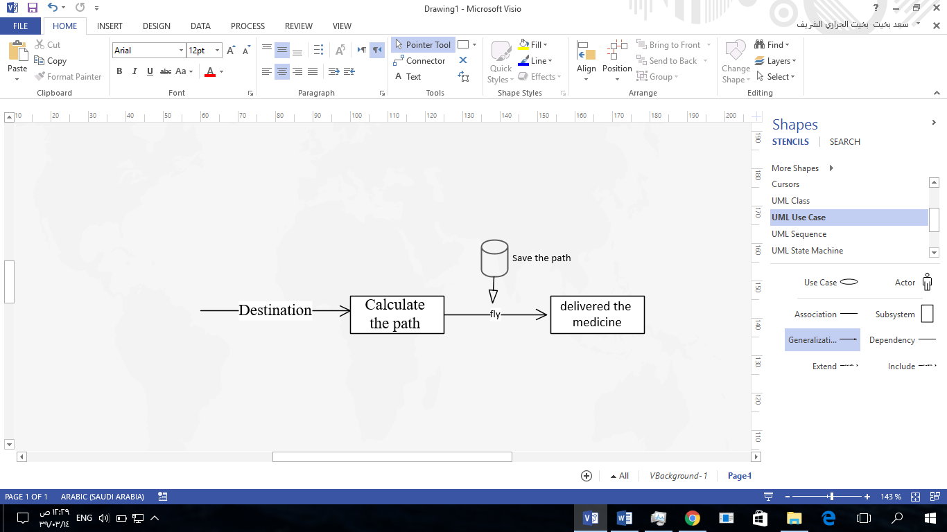

Figure 3.1 - Data Requirements

## Showing how the data going in the project and how will determine the destination

## 3.4 Software :-

* Drone kit simulator.
* Linux os.
* Python.
* Qground control (ground station)

## 

## 3.5 Activities and Actions

### 3.5.2 Flowchart :-

Figure 3.2 shows the necessary steps to determine the shortest path “The flow chart which explains to you how the system will work”



Figure 3.2 - Flowchart

**Tool (software) used for design :-**

Microsoft Visio .

**Chapter 4**

**Implementation**

# Chapter 4 : Implementation

In Implementation phase I start train in the drone kit simulator to do deliver thorough normal mission by give way point Manually after that I trying to implemented in A star algorithm by give start and end points through real map but I don’t find map with Obstacles avidins and to solve it I did grid map and applying the algorithm through random Obstacles by give start and end points and show me the shortest path between it and I have apply unity simulator to show movement of the drone through building.

## Tools & technologies

**Software:-**

* Drone kit simulator.
* Linux OS.
* Python.
* Qground control (ground station).
* Microsoft Visio (To design the project).

**A* algorithm**

**Selected algorithm (A* algorithm) is one of the artificial intelligence (AI) procedures for finding paths. Comparing other AI algorithms, it solves the problems of pathfinding quickly and efficiently. It calculates the shortest path by searching among all possible paths to the solution (goal) for the one that incurs the smallest cost (least distance traveled, shortest time, etc.), and among these paths, it first considers the ones that appear to lead most quickly to the solution. It is formulated regarding weighted graphs: starting from a specific node of a graph, it constructs a tree of paths starting from that node, expanding paths one step at a time, until one of its paths ends at the predetermined goal node.**

## Interface

The interface is a command line interface (because the project is a simulation-based type).

The interface:

* Here The user can see the path of the drone simulator (ground station).

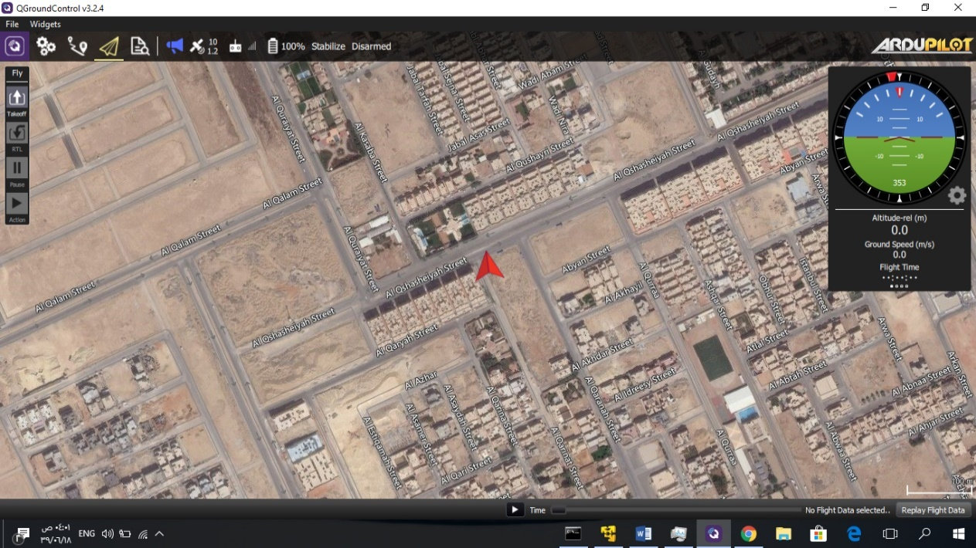

Figure 4.1 - ground station

(ground station): show the GPS stat and can give the drone normal mission by give way point Manually

* Here The user can enter a command to the drone throw mavlink protocol 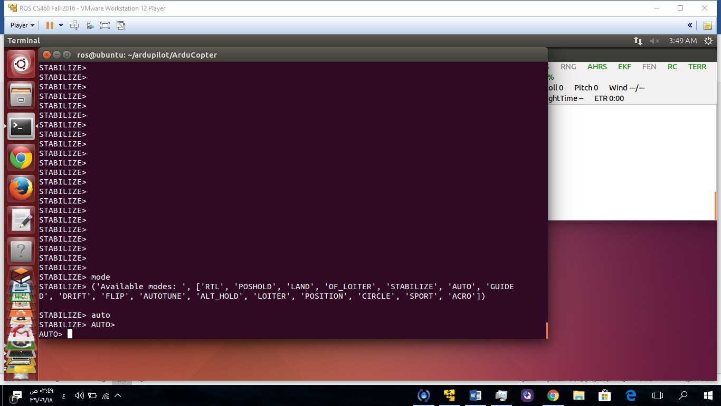 Figure 4.2 – command line for control drone
* Here we can see the information about the drone simulator:

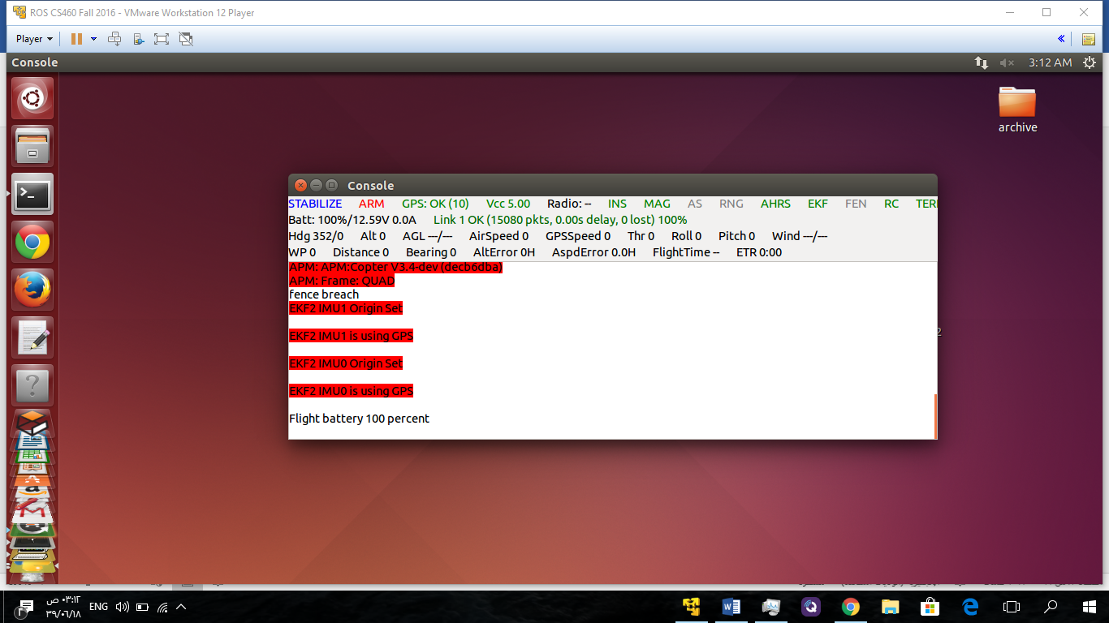

Figure 4.3 **Drone kit simulator**

In drone simulator console can show multiple info like battery

* Here the script of algorithm applying on a grid map

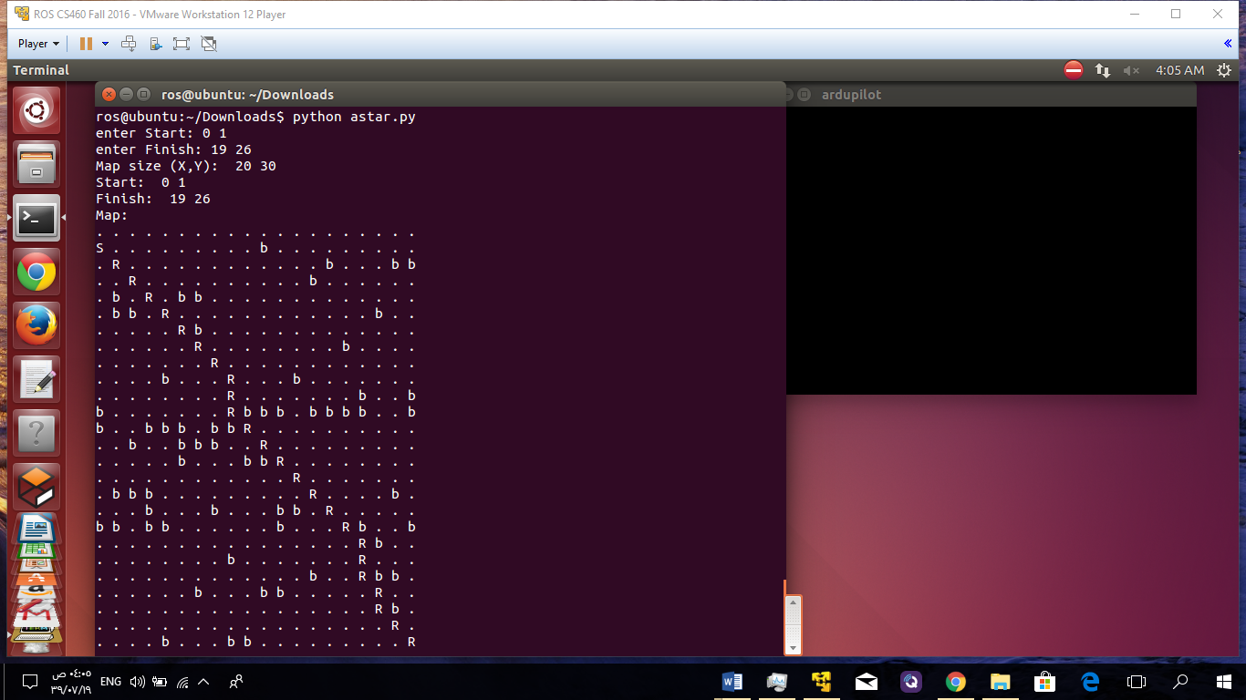

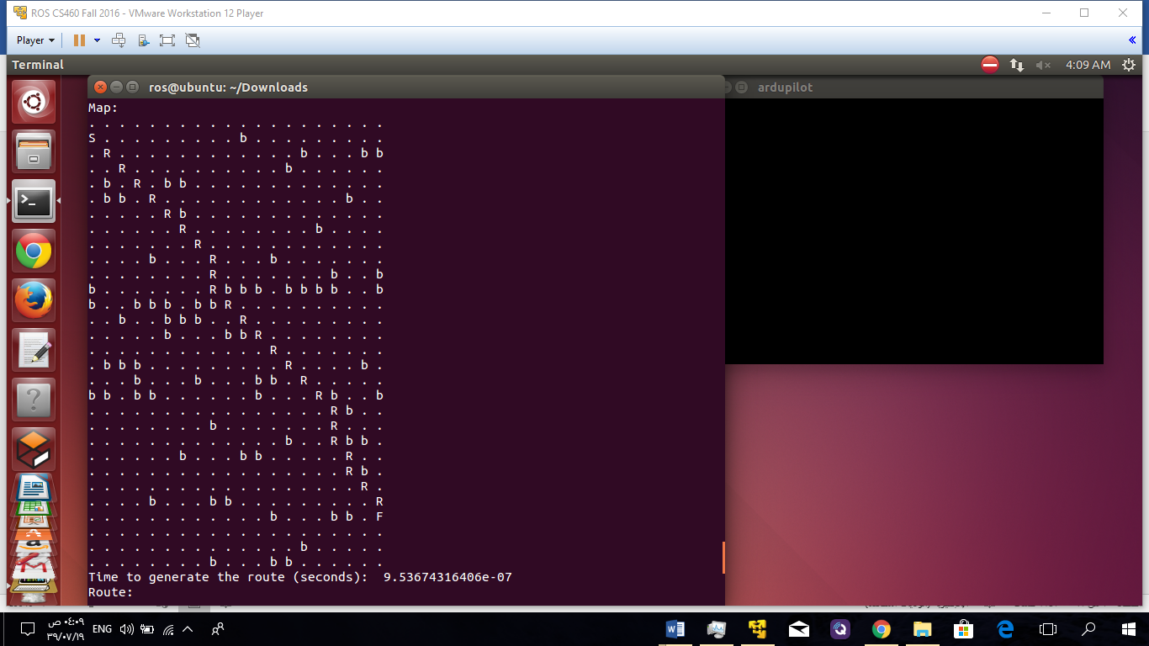

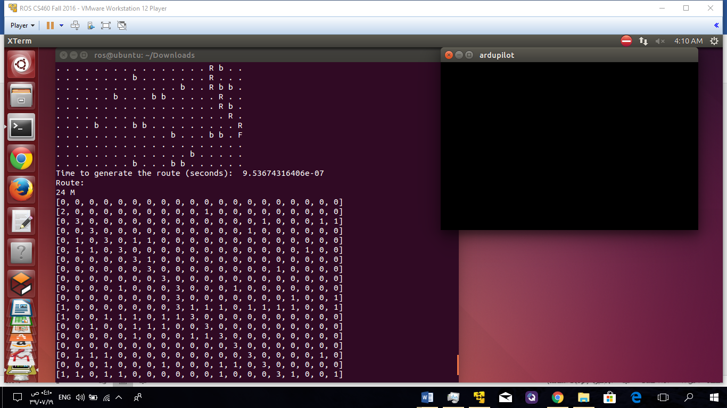

Figure 4.4 - **Script of python in the grid map**

This the grid map I have applied the algorithm and show the distance and time cost to fly through the random obstacle.

Explosions of letter in the grid:

S: start point

R: Route of the drone

b: obstacle like tree or building

F: Finish point (Destination)

* Here the script of algorithm applying on a unity simulator map

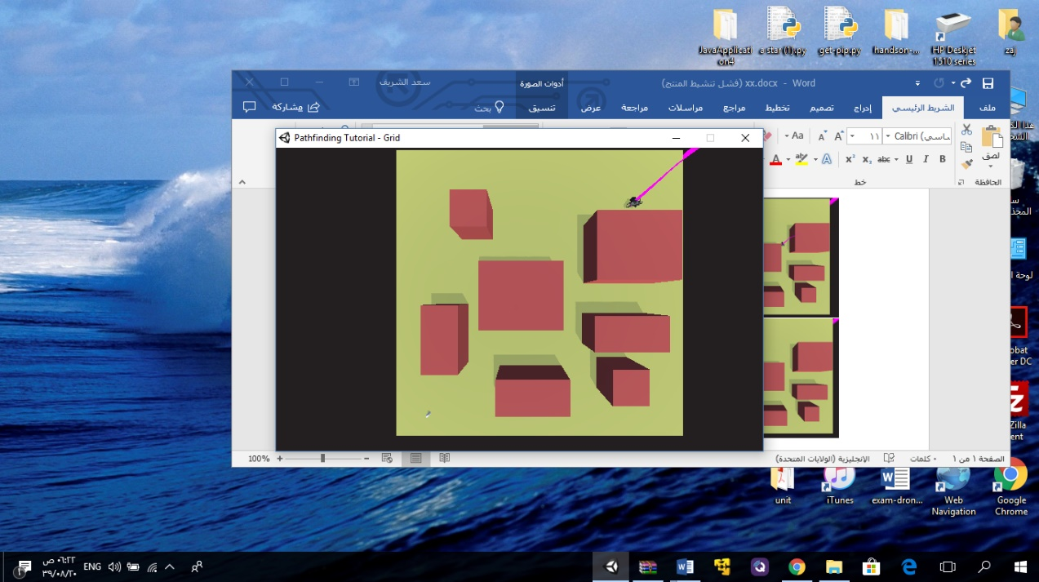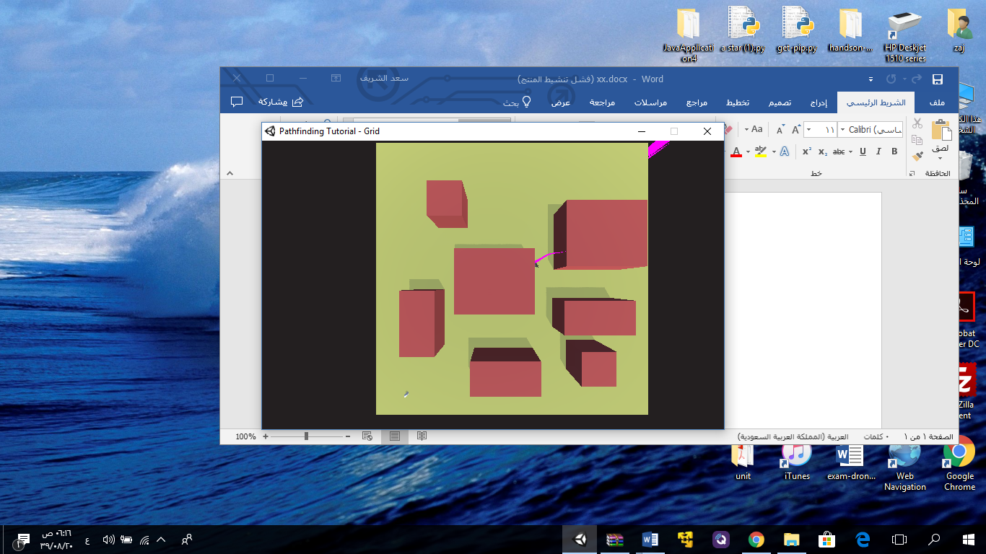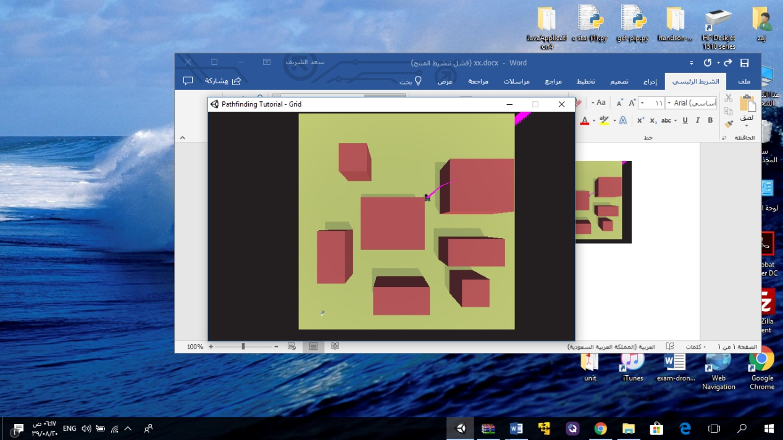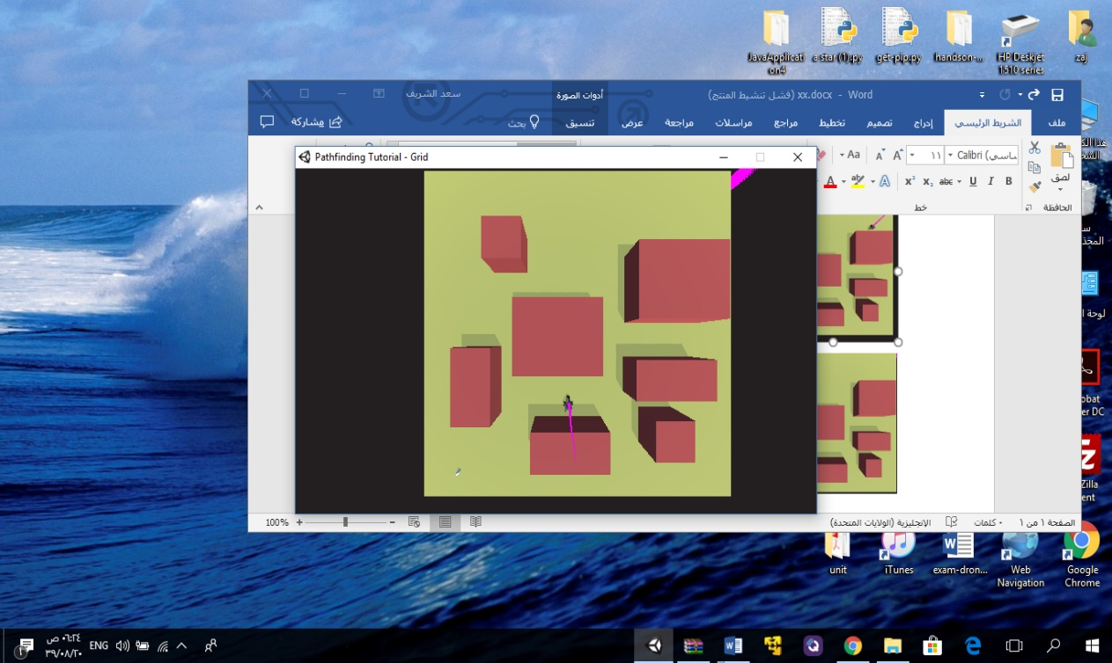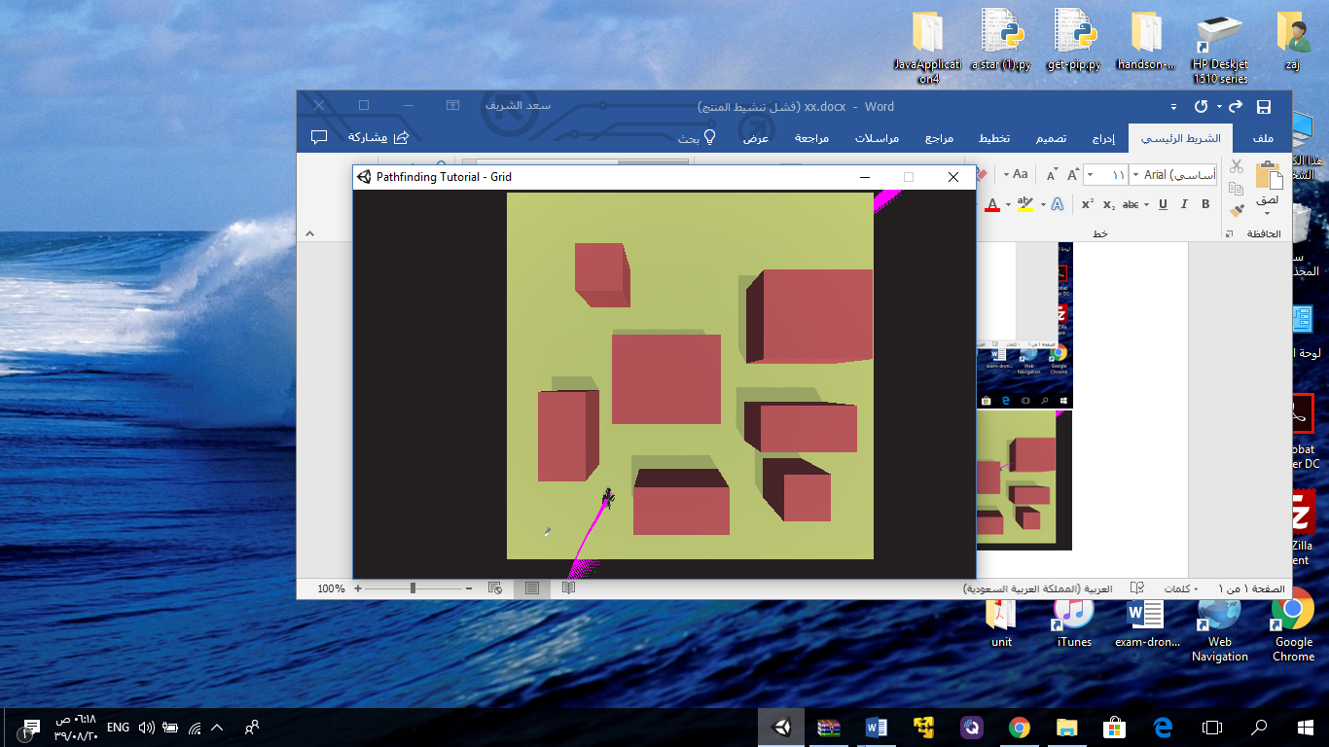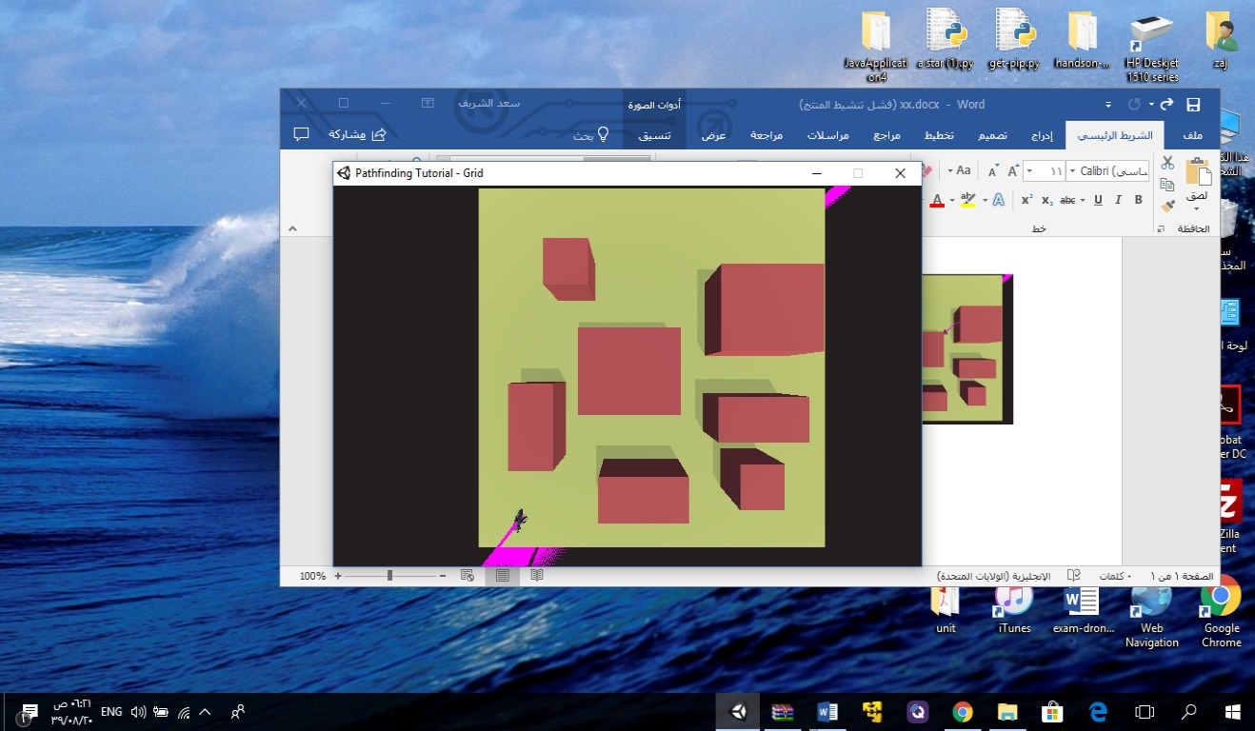

The unity simulator will show the movement of the drone through the building by using A star shortest path algorithm.

Figure 4.5 - **Unity simulator**

# 

# Chapter 5

# Testing

# Testing

Here, I have done the unit test in order to test many situations of the system to check the correctness of the results. I check the correctness of the results by comparing the results accuracy of the algorithm

**The test cases:**

* **Location :**

First case:

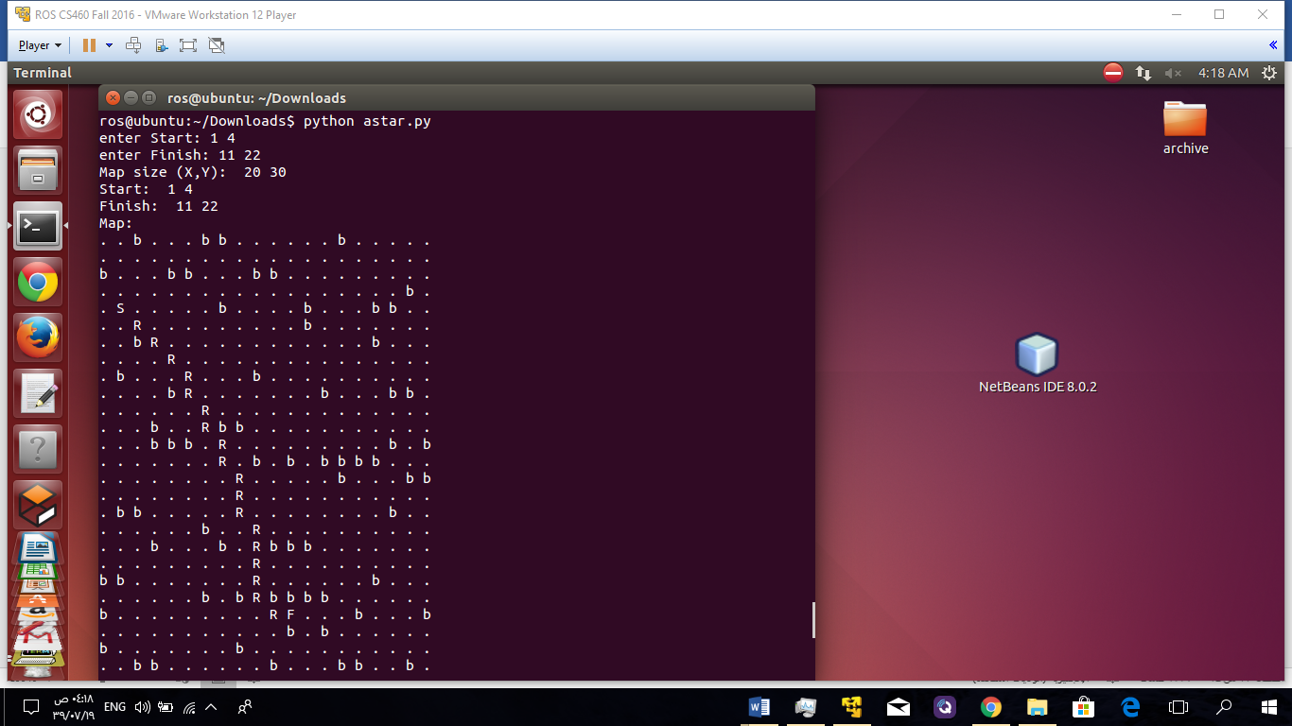

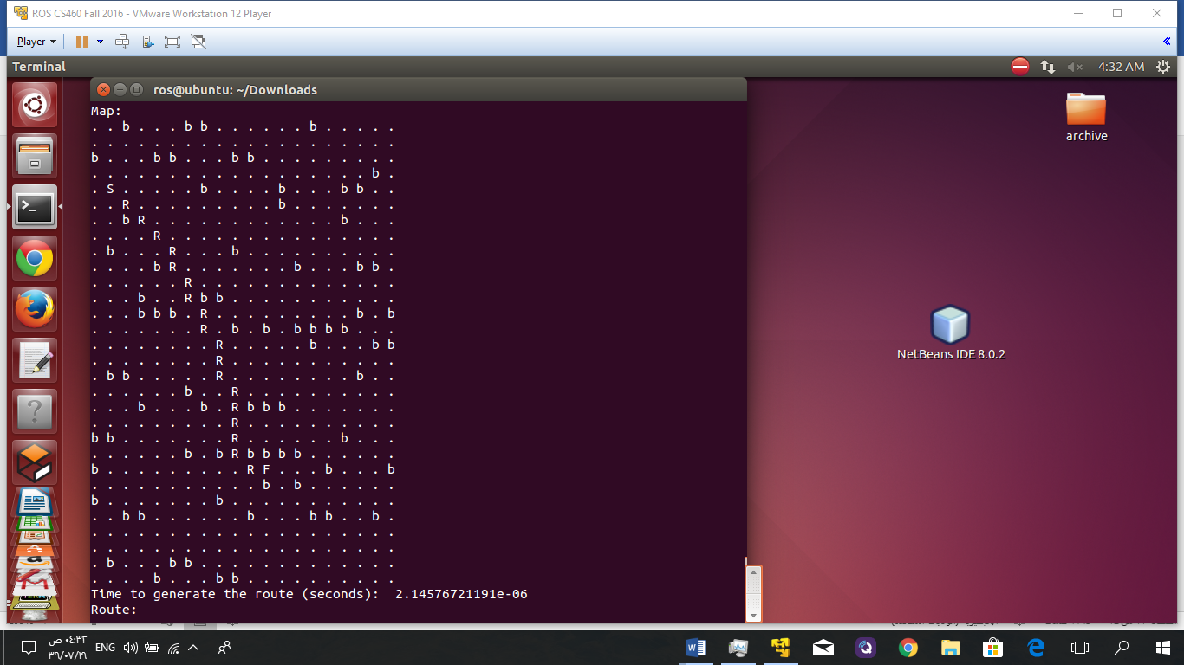

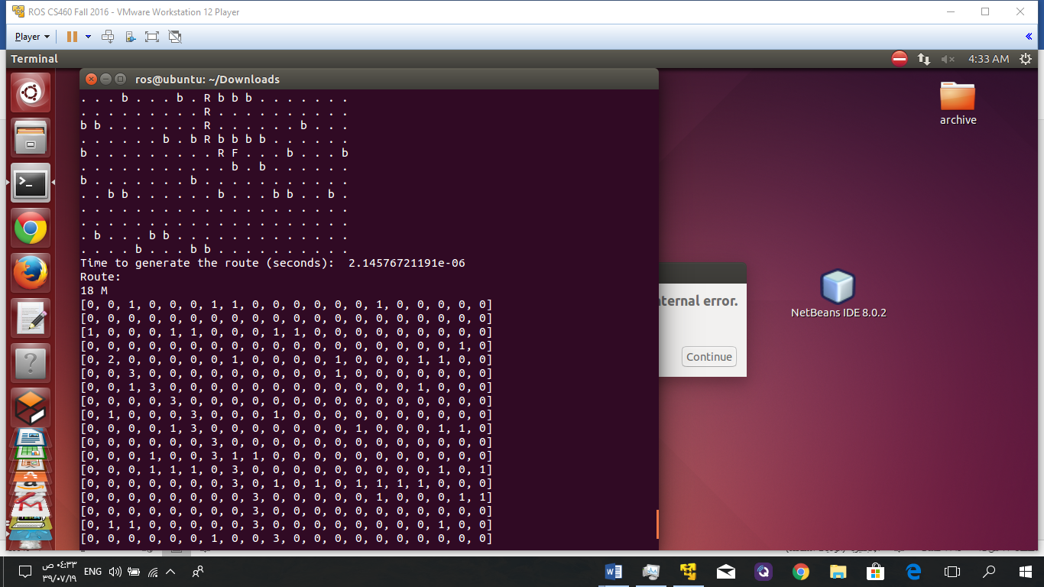

Figure 5.1 - **First case in testing**

Here I give start and end points with random Obstacles and compare the result with another test .

Second case:

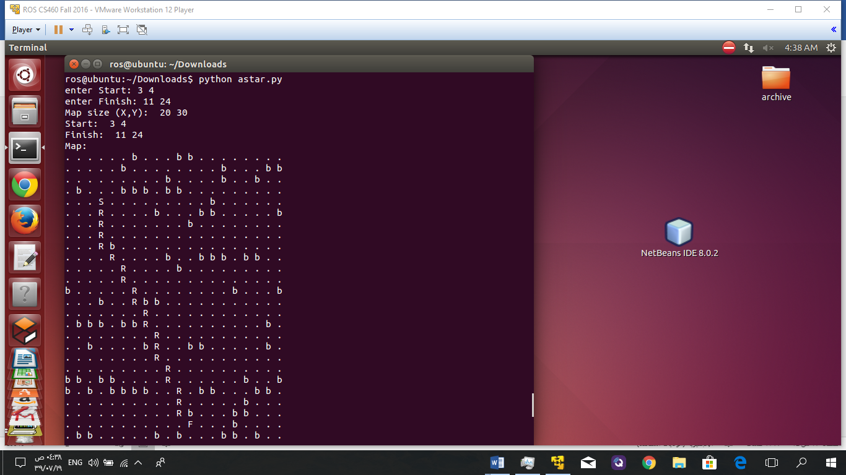

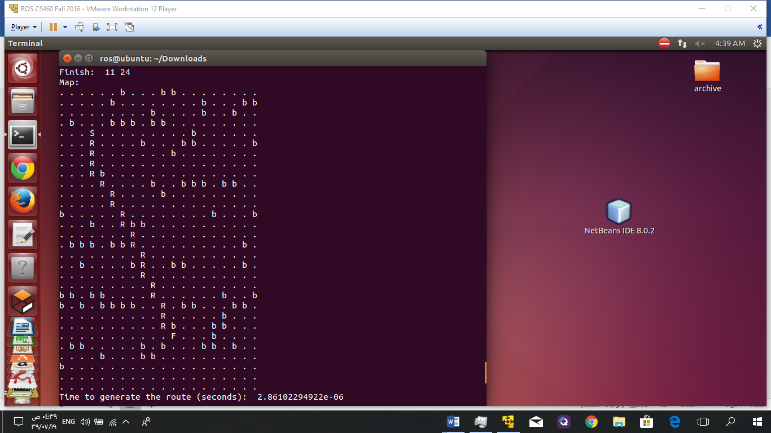

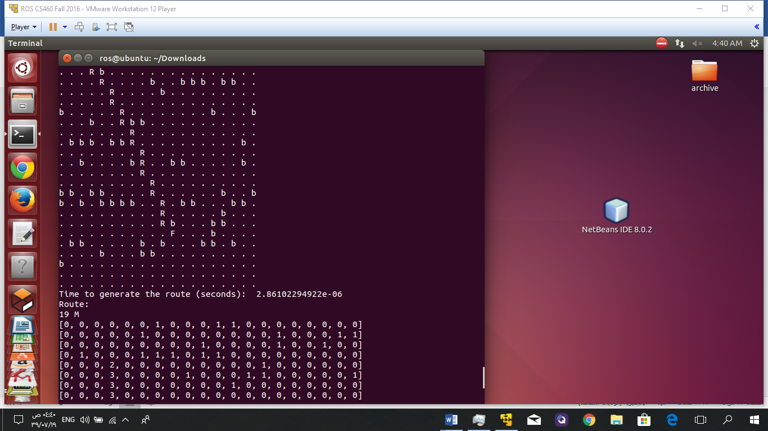

Here I give start and end points with static Obstacles and compare the result with another test .

Figure 5.2 - **Second case in testing**

Third case:

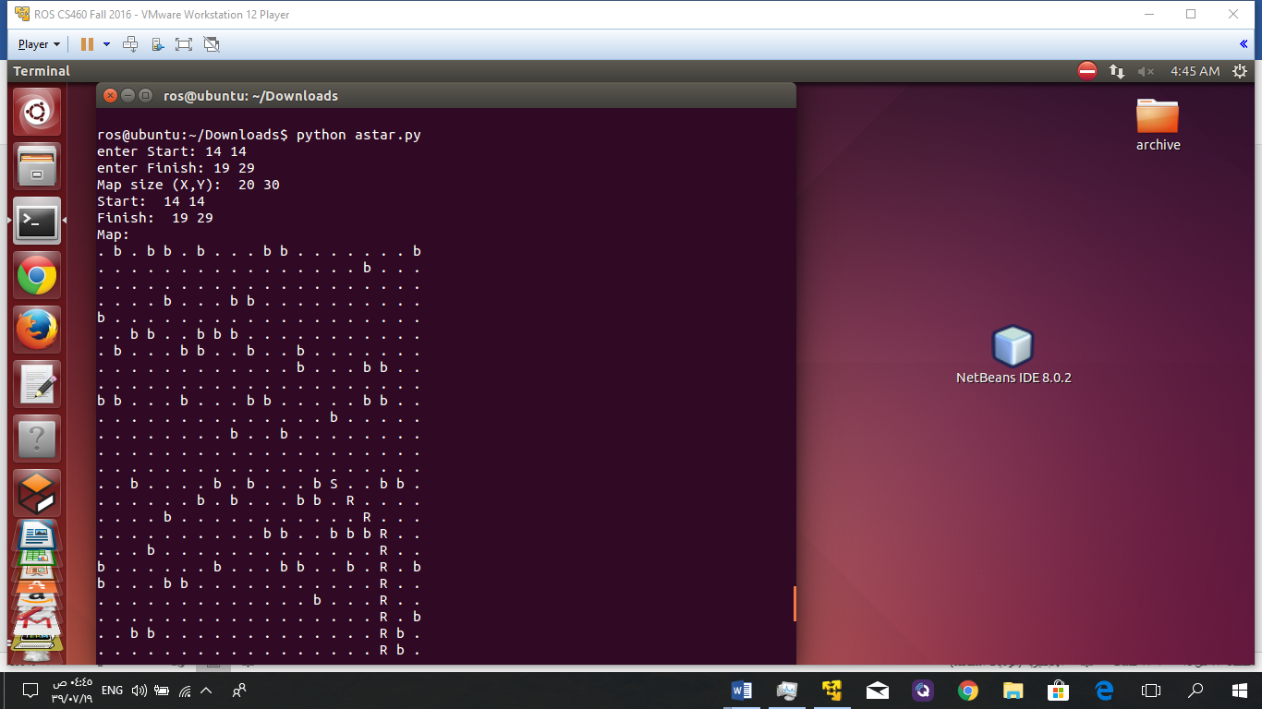

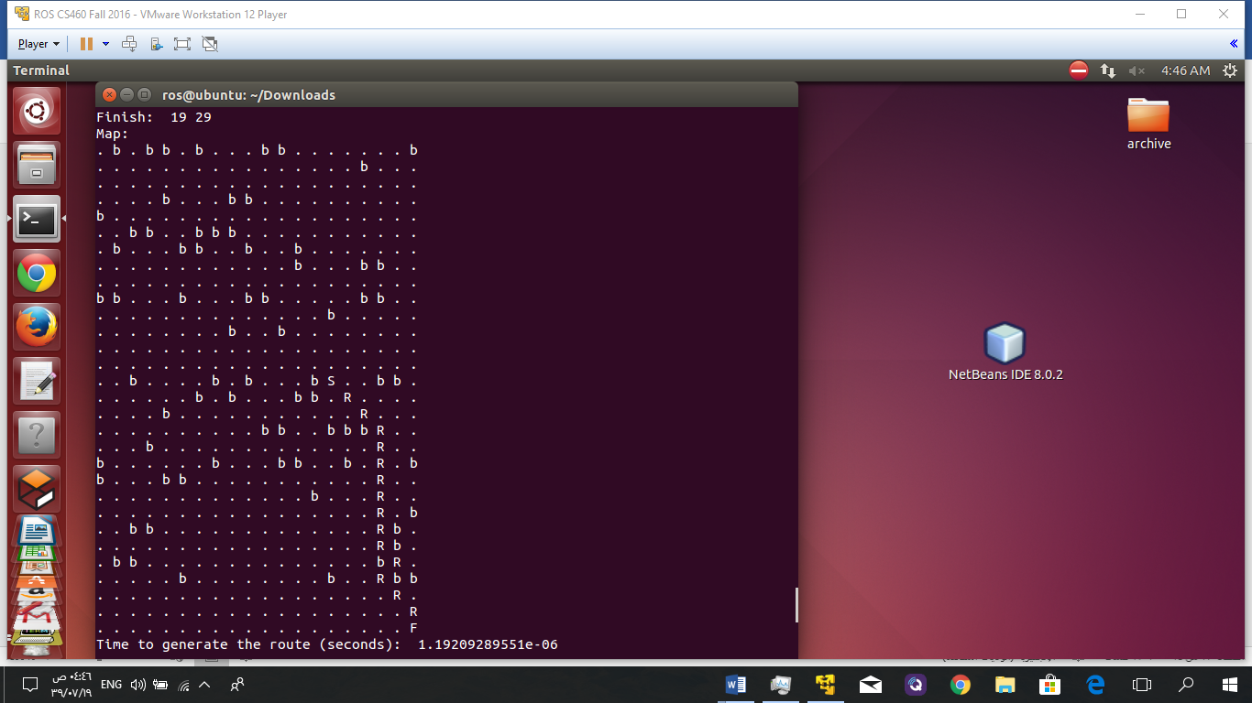

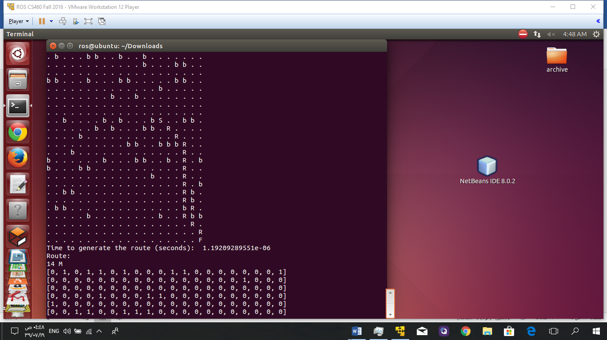

Here I give start and end points with static and random Obstacles and compare the result with another test.

Figure 5.3 - **Third case in testing**

**Conclusion for the testing phase**

The results were good ,reasonable and as expected. So the system works perfectly. Further, we will try to improve it using real maps as a future work.

# Chapter 6

# Conclusion

# Chapter 6 : Conclusion

**In the end, the outcomes of the project are:**

* Learn new thing about drone.
* Resolve a very common problem in the field of delivering medication to a remote village.
* Learn how to apply A* algorithm in the grid map.
* Learn about simulator in unity platform in the project.
* Learn Linux operating system and python platform.

**List of References**

**References**

[1] Brito, V., Brito Palma, L. F. F., Vieira Coito, F., &amp; Valtchev, S. (2016). Modeling a Supervisory Control of a Virtual X8-VB Quadcopter. In 17th International Conference on Power Electronics and Motion Control (p. 8). Varna, Bulgária.

[2] DroneKit-Python 2.x helps you create powerful apps for drone <http://python.dronekit.io/>

[3] is an advanced open-source autopilot system for multicopters, helicopters, and other rotor vehicles.It offers a [wide variety of flight modes](http://ardupilot.org/copter/docs/flight-modes.html#flight-modes) from fully manual to fully autonomous. <http://ardupilot.org/copter/>

[4]

<https://www.mathworks.com/videos/quadcopter-simulation-and-control-made-easy-93365.html>

[5] <https://www.mathworks.com/matlabcentral/fileexchange/12850-dijkstra-s-shortest-path-algorithm>

[6] <https://www.dronesinhealthcare.com/>

**Appendix A**

**(Code python)**

**Appendix A**

The code :

from heapq import heappush, heappop # for the priority queue

import math

import random

import time

class node:

xPos = 0 # x position

yPos = 0 # y position

distance = 0 # total distance already travelled to reach the node

priority = 0 # priority = distance + remaining distance estimate

def __init__(self, xPos, yPos, distance, priority):

self.xPos = xPos

self.yPos = yPos

self.distance = distance

self.priority = priority

def __lt__(self, other): # comparison method for priority queue

return self.priority < other.priority

def updatePriority(self, xDest, yDest):

self.priority = self.distance + self.estimate(xDest, yDest) * 10 # A*

# give higher priority to going straight instead of diagonally

def nextMove(self, dirs, d): # d: direction to move

if dirs == 8 and d % 2 != 0:

self.distance += 14

else:

self.distance += 10

# Estimation function for the remaining distance to the goal.

def estimate(self, xDest, yDest):

xd = xDest - self.xPos

yd = yDest - self.yPos

# Euclidian Distance

d = math.sqrt(xd * xd + yd * yd)

return(d)

# A star algorithm.

# The path returned will be a string of digits of directions.

def pathFind(the_map, n, m, dirs, dx, dy, xA, yA, xB, yB):

closed_nodes_map = [] # map of closed (tried-out) nodes

open_nodes_map = [] # map of open (not-yet-tried) nodes

dir_map = [] # map of dirs

row = [0] * n

for i in range(m): # create 2d arrays

closed_nodes_map.append(list(row))

open_nodes_map.append(list(row))

dir_map.append(list(row))

pq = [[], []] # priority queues of open (not-yet-tried) nodes

pqi = 0 # priority queue index

# create the start node and push into list of open nodes

n0 = node(xA, yA, 0, 0)

n0.updatePriority(xB, yB)

heappush(pq[pqi], n0)

open_nodes_map[yA][xA] = n0.priority # mark it on the open nodes map

# A* search

while len(pq[pqi]) > 0:

# get the current node w/ the highest priority

# from the list of open nodes

n1 = pq[pqi][0] # top node

n0 = node(n1.xPos, n1.yPos, n1.distance, n1.priority)

x = n0.xPos

y = n0.yPos

heappop(pq[pqi]) # remove the node from the open list

open_nodes_map[y][x] = 0

closed_nodes_map[y][x] = 1 # mark it on the closed nodes map

# quit searching when the goal is reached

# if n0.estimate(xB, yB) == 0:

if x == xB and y == yB:

# generate the path from finish to start

# by following the dirs

path = ''

while not (x == xA and y == yA):

j = dir_map[y][x]

c = str((j + dirs / 2) % dirs)

path = c + path

x += dx[j]

y += dy[j]

return path

# generate moves (child nodes) in all possible dirs

for i in range(dirs):

xdx = x + dx[i]

ydy = y + dy[i]

if not (xdx < 0 or xdx > n-1 or ydy < 0 or ydy > m - 1

or the_map[ydy][xdx] == 1 or closed_nodes_map[ydy][xdx] == 1):

# generate a child node

m0 = node(xdx, ydy, n0.distance, n0.priority)

m0.nextMove(dirs, i)

m0.updatePriority(xB, yB)

# if it is not in the open list then add into that

if open_nodes_map[ydy][xdx] == 0:

open_nodes_map[ydy][xdx] = m0.priority

heappush(pq[pqi], m0)

# mark its parent node direction

dir_map[ydy][xdx] = (i + dirs / 2) % dirs

elif open_nodes_map[ydy][xdx] > m0.priority:

# update the priority

open_nodes_map[ydy][xdx] = m0.priority

# update the parent direction

dir_map[ydy][xdx] = (i + dirs / 2) % dirs

# replace the node

# by emptying one pq to the other one

# except the node to be replaced will be ignored

# and the new node will be pushed in instead

while not (pq[pqi][0].xPos == xdx and pq[pqi][0].yPos == ydy):

heappush(pq[1 - pqi], pq[pqi][0])

heappop(pq[pqi])

heappop(pq[pqi]) # remove the target node

# empty the larger size priority queue to the smaller one

if len(pq[pqi]) > len(pq[1 - pqi]):

pqi = 1 - pqi

while len(pq[pqi]) > 0:

heappush(pq[1-pqi], pq[pqi][0])

heappop(pq[pqi])

pqi = 1 - pqi

heappush(pq[pqi], m0) # add the better node instead

return '' # if no route found

# MAIN

dirs = 8 # number of possible directions to move on the map

if dirs == 4:

dx = [1, 0, -1, 0]

dy = [0, 1, 0, -1]

elif dirs == 8:

dx = [1, 1, 0, -1, -1, -1, 0, 1]

dy = [0, 1, 1, 1, 0, -1, -1, -1]

n = 20 # horizontal size of the map

m = 30 # vertical size of the map

the_map = []

row = [0] * n

for i in range(m): # create empty map

the_map.append(list(row))

# fillout the map with a random obstacle pattern

for x in range(n):

r1=random.randint(0, m-1)#defind random obstacle

the_map[r1][x] = 1

the_map[r1][x-1] = 1

the_map[r1][x-5] = 1

the_map[random.randint(0, m-2)][x] = 1

the_map[m / 2][n/2]=0

the_map[m / 4][n/8]=0

# Enter start and finish locations to the list

us = raw_input("enter Start: ").split(' ')

os = raw_input("enter Finish: ").split(' ')

us = map(int, us)

os = map(int, os)

xA = us[0]

yA = us[1]

xB = os[0]

yB = os[1]

#print info about map

print 'Map size (X,Y): ', n, m

print 'Start: ', xA, yA

print 'Finish: ', xB, yB

route = pathFind(the_map, n, m, dirs, dx, dy, xA, yA, xB, yB)

# mark the route on the map

if len(route) > 0:

x = xA

y = yA

the_map[y][x] = 2

for i in range(len(route)):

j = int(route[i])

x += dx[j]

y += dy[j]

the_map[y][x] = 3

the_map[y][x] = 4

# display the map with the route added

i=0

print 'Map:'

for y in range(m):

for x in range(n):

xy = the_map[y][x]

if xy == 0:

print '.', # space

elif xy == 1:

print 'b', # obstacle

elif xy == 2:

print 'S', # start

elif xy == 3:

print 'R', # route

i=i+1

elif xy == 4:

print 'F', # finish

print

t = time.time()

print 'Time to generate the route (seconds): ', time.time() - t # print time cost

print 'Route:'

print i ,'M' , # print route

print

for i in range(len(the_map)):

print the_map[i]